**Project Design Phase-II**

**Data Flow Diagram & User Stories**

|  |  |
| --- | --- |
| Date | 27 june 2025 |
| Team ID | LTVIP2025TMID59173 |
| Project Name | HealthAI: Intelligent Healthcare Assistant Using IBM Granite |
| Maximum Marks | 4 Marks |

**Data Flow Diagrams:**

A Data Flow Diagram (DFD) is a traditional visual representation of the information flows within a system. A neat and clear DFD can depict the right amount of the system requirement graphically. It shows how data enters and leaves the system, what changes the information, and where data is stored.

**Example:** [**(Simplified)**](https://developer.ibm.com/patterns/visualize-unstructured-text/)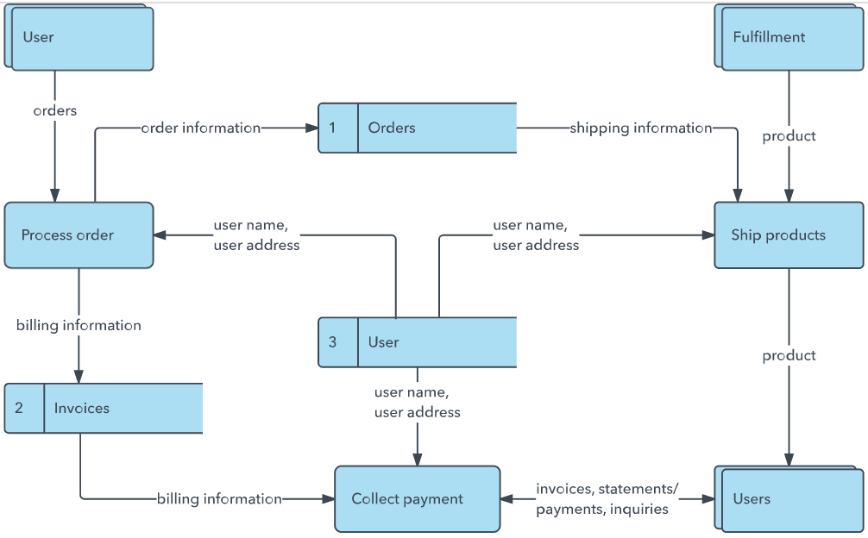

**User Stories – Health AI**

|  |  |  |  |  |  |  |
| --- | --- | --- | --- | --- | --- | --- |
| **User Type** | **Functional Requirement (Epic)** | **User Story Number** | **User Story / Task** | **Acceptance Criteria** | **Priority** | **Release** |
| **Customer (Mobile User)** | Registration | USN-1 | As a user, I can register for the application by entering my email, password, and confirming my password. | I can access my account/dashboard | High | Sprint-1 |
|  | Registration | USN-2 | As a user, I will receive a confirmation email once I have registered for the application. | I receive the confirmation email & can click to confirm | High | Sprint-1 |
|  | Registration | USN-3 | As a user, I can register for the application through Facebook. | I can register & access the dashboard with Facebook login | Low | Sprint-2 |
|  | Registration | USN-4 | As a user, I can register for the application through Gmail. | I can register and log in using my Gmail credentials | Medium | Sprint-1 |
|  | Login | USN-5 | As a user, I can log into the application by entering email and password. | I can securely log in and view my dashboard | High | Sprint-1 |
|  | Dashboard | USN-6 | As a user, I can view my health records, AI disease predictions, and health graphs. | I see updated data and AI predictions after login | High | Sprint-2 |
|  | Health AI Chat | USN-7 | As a user, I can chat with an AI to ask about my symptoms or health concerns. | AI responds with meaningful answers related to my health | High | Sprint-2 |
|  | Health Trends | USN-8 | As a user, I can see graphs of my vital health parameters over time. | Graphs display trends for heart rate, BP, glucose, etc. | Medium | Sprint-3 |

| **Customer (Web User)** | Registration/Login/Dashboard | USN-9 | As a web user, I can register, login, and use all features similar to mobile. | Features work seamlessly on web version | High | Sprint-2 |  
| | Appointment Booking | USN-10 | As a user, I can book appointments with a doctor through the web dashboard. | Appointment is scheduled and confirmed | Medium | Sprint-3 |

| **Customer Care Executive** | Patient Management | USN-11 | As an executive, I can view and manage patient queries from the AI chat system. | I can respond or escalate unresolved issues | High | Sprint-2 |  
| | Report Generation | USN-12 | As an executive, I can download or email a summary of patient health data. | Reports are generated and sent correctly | Medium | Sprint-3 |

| **Administrator** | User Management | USN-13 | As an admin, I can manage user accounts (activate, deactivate, remove). | Admin can see all user actions and control access | High | Sprint-1 |  
| | Analytics | USN-14 | As an admin, I can view overall analytics of AI performance and health trends. | I can monitor the system through graphs and reports | Medium | Sprint-3 |  
| | System Configuration | USN-15 | As an admin, I can configure AI model versions, health thresholds, and set permissions. | Changes apply system-wide correctly | Medium | Sprint-3 |